Conexión de Java con MySQL para la Gestión de Alumnos ²

- ^{Main:}
package app;
import Controller.StudentController;
public class Main {
public static void main(String[] args) {
new StudentController().start();
}
}

- ^{Student.java:}
- package model;
public class Student {
private int id;
private String lastName;
private String firstName;
private String dni;
private String address;
private String birthDate;
private double grade;
public Student(int id, String lastName, String firstName, String dni, String address, String birthDate, double grade) {
this.id = id;
this.lastName = lastName;
this.firstName = firstName;
this.dni = dni;
this.address = address;
this.birthDate = birthDate;
this.grade = grade;
}
public int getId() { return id; }
public String getLastName() { return lastName; }
public String getFirstName() { return firstName; }
public String getDni() { return dni; }
public String getAddress() { return address; }
public String getBirthDate() { return birthDate; }
public double getGrade() { return grade; }
}

- ^{StudentDAO.java:}
- package model;
import java.sql.*;
import java.util.ArrayList;
public class StudentDAO {
private final String url = "jdbc:mysql://localhost:3306/studentsdb";
private final String user = "root";
private final String pass = "";
public Connection connect() throws SQLException {
return DriverManager.getConnection(url, user, pass);
}
public void insert(Student s) throws SQLException {
Connection cn = connect();
cn.setAutoCommit(false);
PreparedStatement ps = cn.prepareStatement("INSERT INTO students VALUES (?,?,?,?,?,?,?)");
ps.setInt(1, s.getId());
ps.setString(2, s.getLastName());
ps.setString(3, s.getFirstName());
ps.setString(4, s.getDni());
ps.setString(5, s.getAddress());
ps.setString(6, s.getBirthDate());
ps.setDouble(7, s.getGrade());
ps.executeUpdate();
cn.commit();
cn.close();
}
public ArrayList<Student> listAll() throws SQLException {
Connection cn = connect();
PreparedStatement ps = cn.prepareStatement("SELECT * FROM students");
ResultSet rs = ps.executeQuery();
ArrayList<Student> list = new ArrayList<>();
while (rs.next()) {
list.add(new Student(
rs.getInt("id"),
rs.getString("last_name"),
rs.getString("first_name"),
rs.getString("dni"),
rs.getString("address"),
rs.getString("birth_date"),
rs.getDouble("grade")
));
}
cn.close();
return list;
}
public Student searchByDni(String dni) throws SQLException {
Connection cn = connect();
PreparedStatement ps = cn.prepareStatement("SELECT * FROM students WHERE dni=?");
ps.setString(1, dni);
ResultSet rs = ps.executeQuery();
Student s = null;
if (rs.next()) {
s = new Student(
rs.getInt("id"),
rs.getString("last_name"),
rs.getString("first_name"),
rs.getString("dni"),
rs.getString("address"),
rs.getString("birth_date"),
rs.getDouble("grade")
);
}
cn.close();
return s;
}
public void update(Student s) throws SQLException {
Connection cn = connect();
PreparedStatement ps = cn.prepareStatement(
"UPDATE students SET last_name=?, first_name=?, address=?, birth_date=?, grade=? WHERE dni=?"
);
ps.setString(1, s.getLastName());
ps.setString(2, s.getFirstName());
ps.setString(3, s.getAddress());
ps.setString(4, s.getBirthDate());
ps.setDouble(5, s.getGrade());
ps.setString(6, s.getDni());
ps.executeUpdate();
cn.close();
}
public void delete(String dni) throws SQLException {
Connection cn = connect();
PreparedStatement ps = cn.prepareStatement("DELETE FROM students WHERE dni=?");
ps.setString(1, dni);
ps.executeUpdate();
cn.close();
}
}
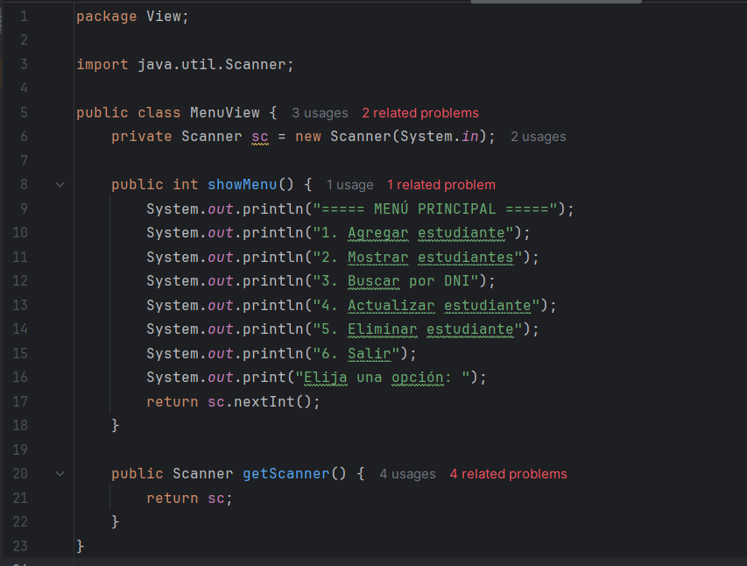
- ^{MenuView:}

- ^{StudentController:}
- package Controller;
import model.Student;
import model.StudentDAO;
import View.MenuView;
public class StudentController {
private MenuView view = new MenuView();
private StudentDAO dao = new StudentDAO();
public void start() {
while (true) {
int op = view.showMenu();
switch (op) {
case 1 -> add();
case 2 -> list();
case 3 -> search();
case 4 -> update();
case 5 -> delete();
case 6 -> System.exit(0);
}
}
}
public void add() {
var sc = view.getScanner();
System.out.print("Código: ");
int id = sc.nextInt();
sc.nextLine();
System.out.print("Apellidos: ");
String ln = sc.nextLine();
System.out.print("Nombres: ");
String fn = sc.nextLine();
System.out.print("DNI: ");
String dni = sc.nextLine();
System.out.print("Dirección: ");
String address = sc.nextLine();
System.out.print("Fecha de nacimiento (YYYY-MM-DD): ");
String bd = sc.nextLine();
System.out.print("Nota: ");
double grade = sc.nextDouble();
try {
dao.insert(new Student(id, ln, fn, dni, address, bd, grade));
} catch (Exception e) {
System.out.println("Ocurrió un error");
}
}
public void list() {
try {
for (Student s : dao.listAll()) {
System.out.println(
s.getId() + " | " +
s.getLastName() + ", " +
s.getFirstName() + " | DNI: " +
s.getDni() + " | Dirección: " +
s.getAddress() + " | Nacimiento: " +
s.getBirthDate() + " | Nota: " +
s.getGrade()
);
}
} catch (Exception e) {
System.out.println("Ocurrió un error");
}
}
public void search() {
var sc = view.getScanner();
System.out.print("DNI a buscar: ");
sc.nextLine();
String dni = sc.nextLine();
try {
Student s = dao.searchByDni(dni);
if (s != null) {
System.out.println(
s.getId() + " | " +
s.getLastName() + ", " +
s.getFirstName() + " | Dirección: " +
s.getAddress() + " | Nacimiento: " +
s.getBirthDate() + " | Nota: " +
s.getGrade()
);
}
} catch (Exception e) {
System.out.println("Ocurrió un error");
}
}
public void update() {
var sc = view.getScanner();
System.out.print("DNI del estudiante a actualizar: ");
sc.nextLine();
String dni = sc.nextLine();
System.out.print("Nuevo apellido: ");
String ln = sc.nextLine();
System.out.print("Nuevo nombre: ");
String fn = sc.nextLine();
System.out.print("Nueva dirección: ");
String address = sc.nextLine();
System.out.print("Nueva fecha de nacimiento (YYYY-MM-DD): ");
String bd = sc.nextLine();
System.out.print("Nueva nota: ");
double grade = sc.nextDouble();
try {
dao.update(new Student(0, ln, fn, dni, address, bd, grade));
} catch (Exception e) {
System.out.println("Ocurrió un error");
}
}
public void delete() {
var sc = view.getScanner();
System.out.print("DNI del estudiante a eliminar: ");
sc.nextLine();
String dni = sc.nextLine();
try {
dao.delete(dni);
} catch (Exception e) {
System.out.println("Ocurrió un error");
}
}
}

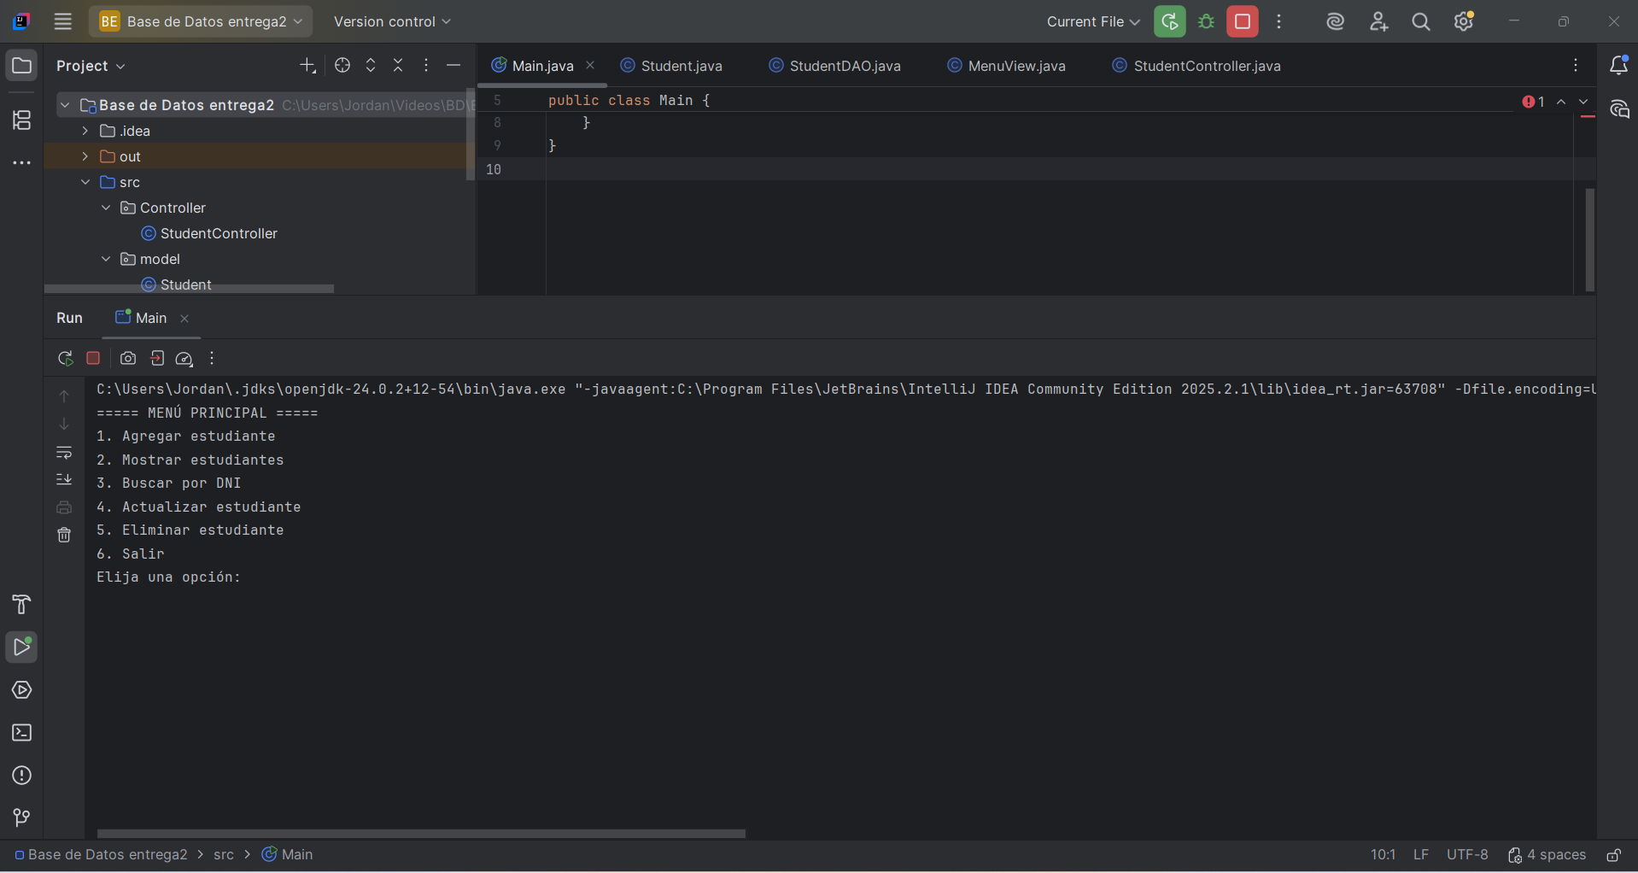
- ^{Menú en ejecución:}

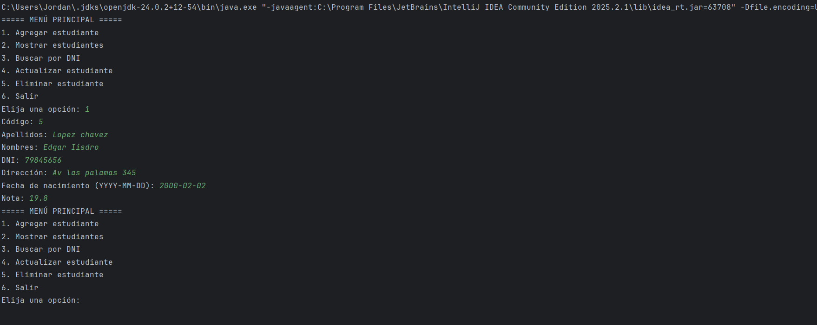
- ^{Ejecución opción 1:}

}

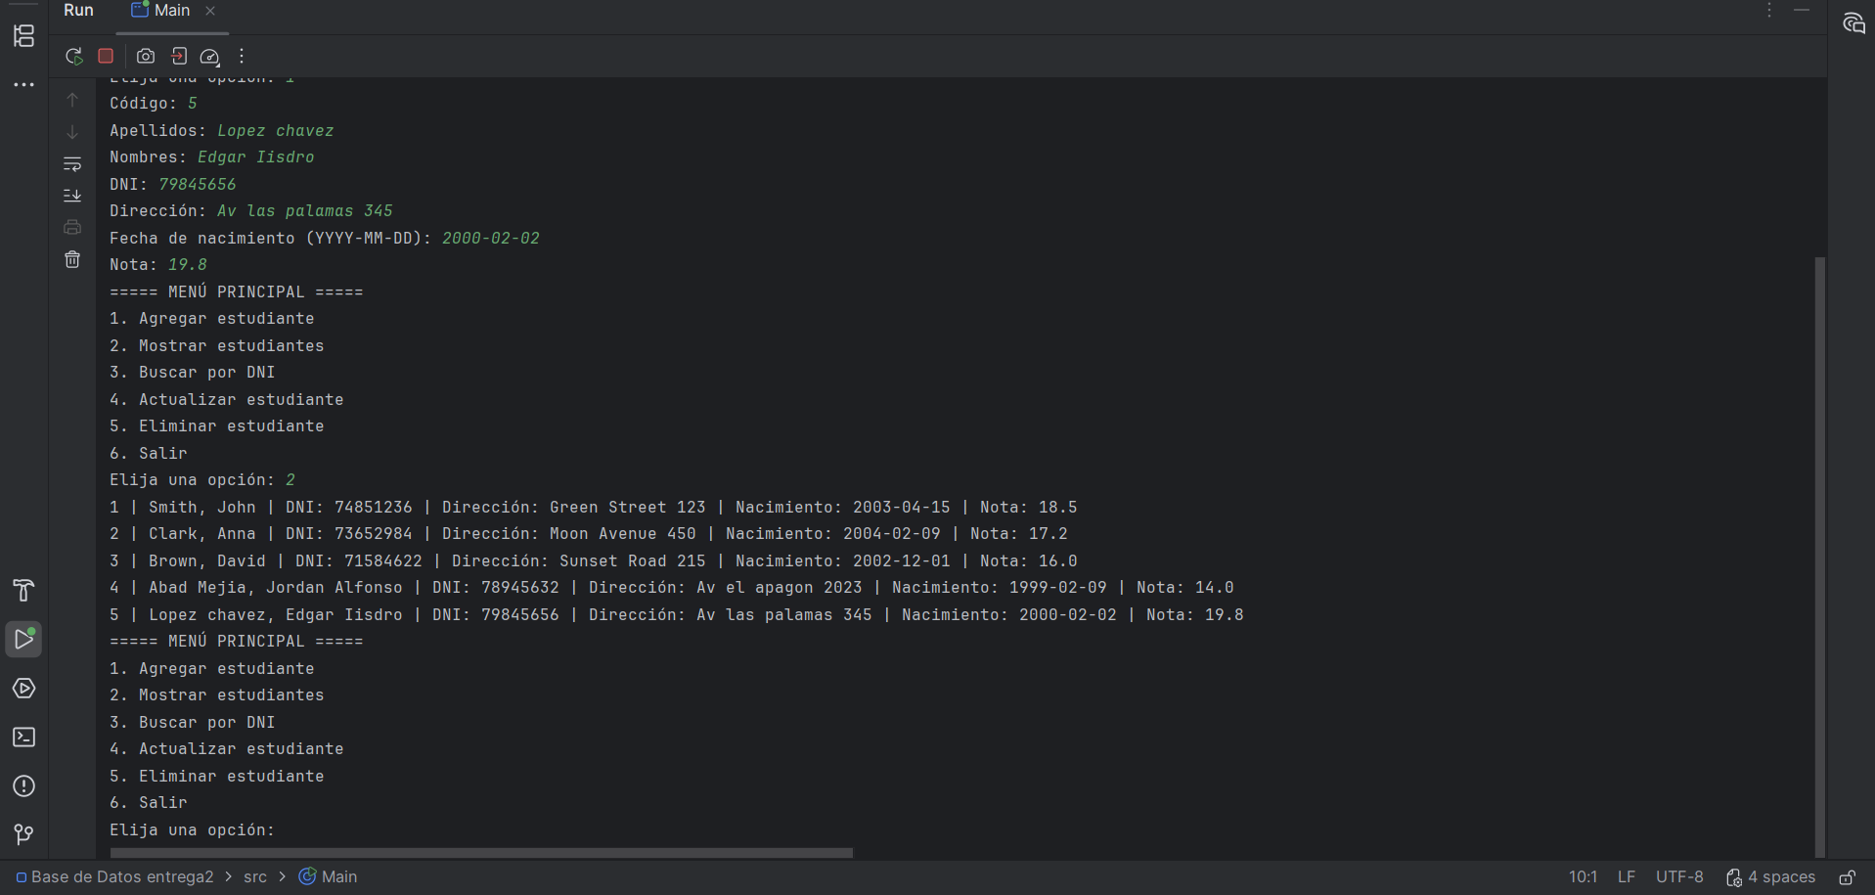
- ^{Ejecución opción 2:}

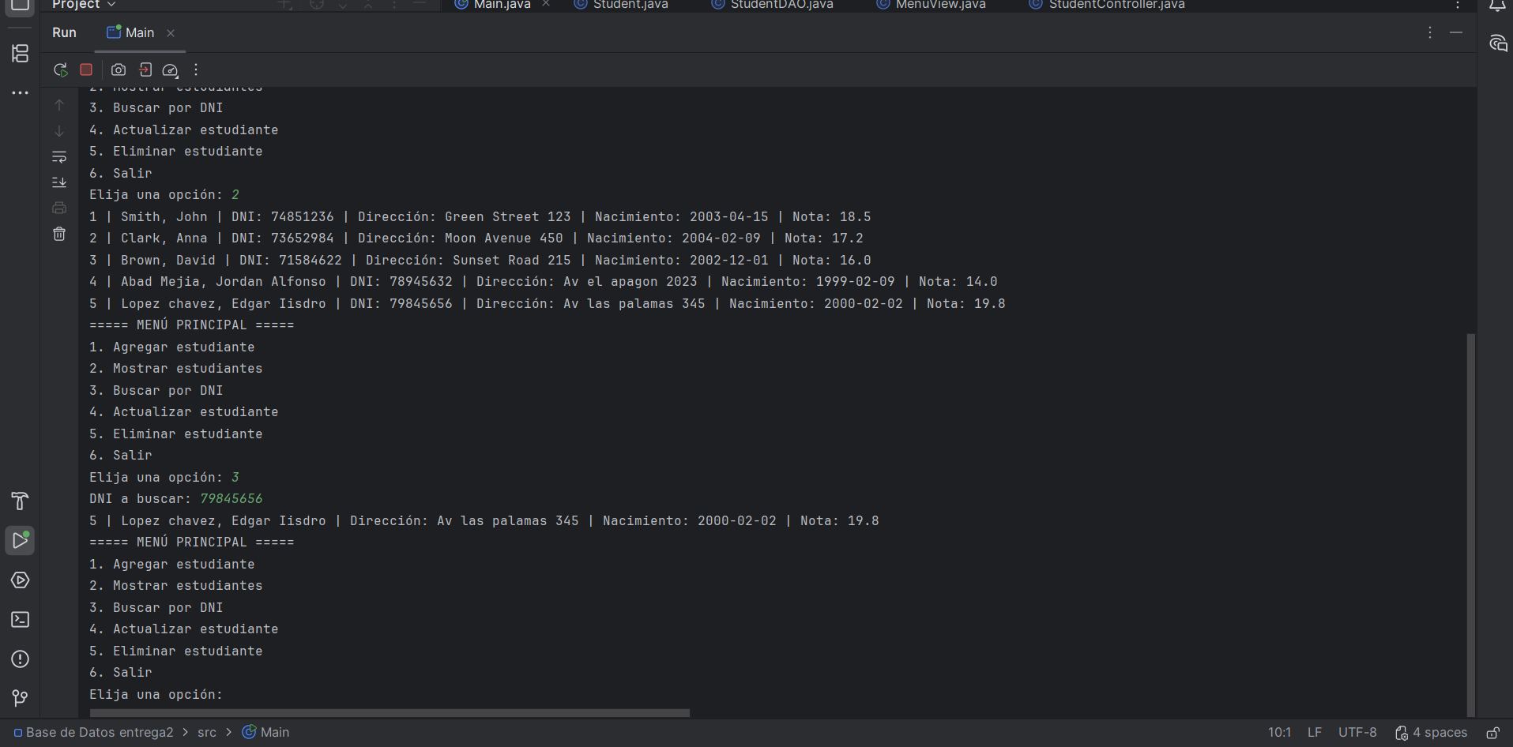
- ^{Ejecución opción 3:}

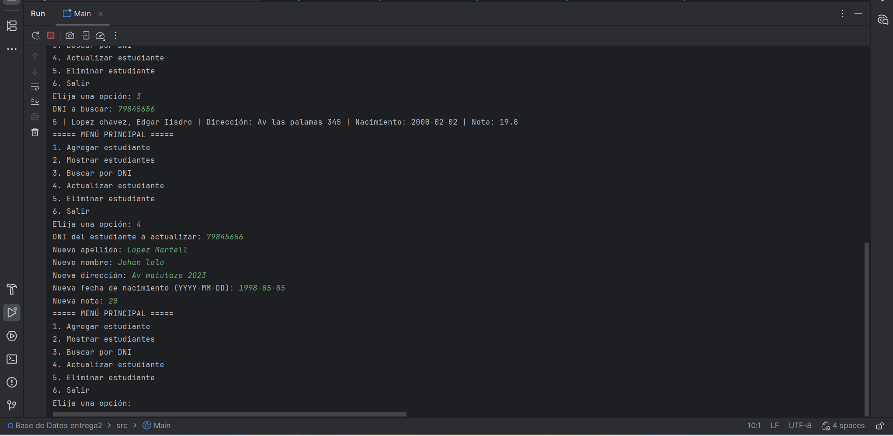
- ^{Ejecución opción 4:}

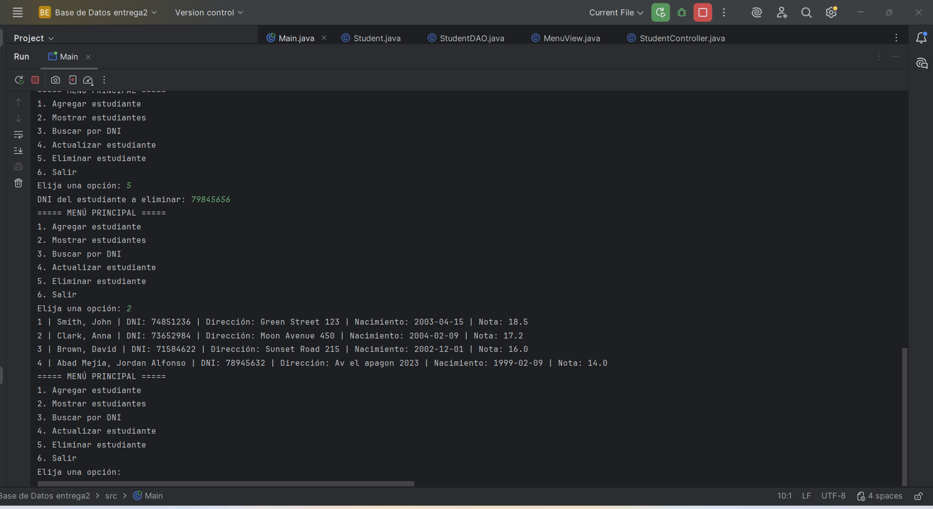
- ^{Ejecución opción 5:}

- ^{Código SQL:}
